**Capture and Analyze Network Traffic Using Wireshark**

1.Install Wireshark

Download Wireshark from <https://www.wireshark.org/download.html> and install it.

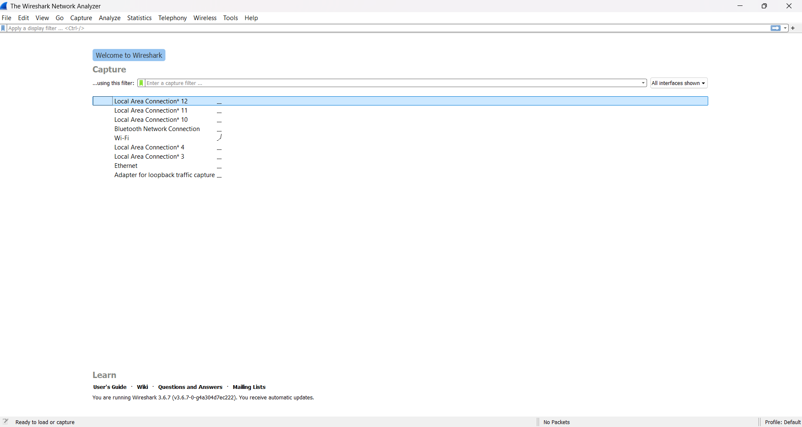

2.Start capturing on your active network interface.

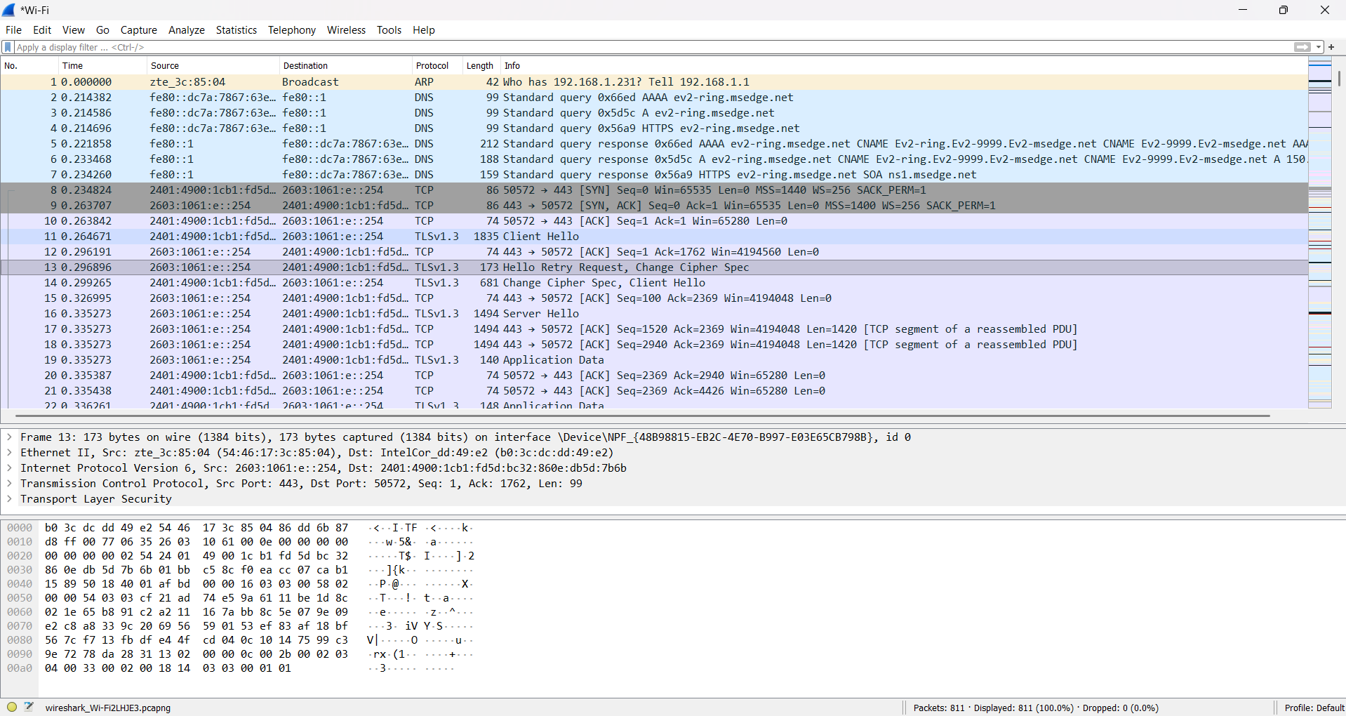

3.Browse a website or ping a server to generate traffic.

If there is no traffic in your network you can generate it by pinging a server or browsing a website.

4.Stop capture after a minute.

Tap capture and select stop to stop capturing.

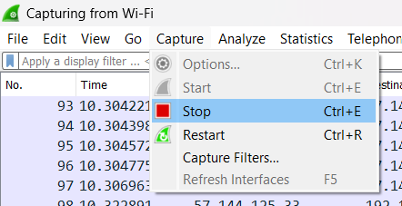

5.Filter captured packets by protocol (e.g., HTTP, DNS, TCP).

In display filter which is in top you can search with protocols or ip addresses.

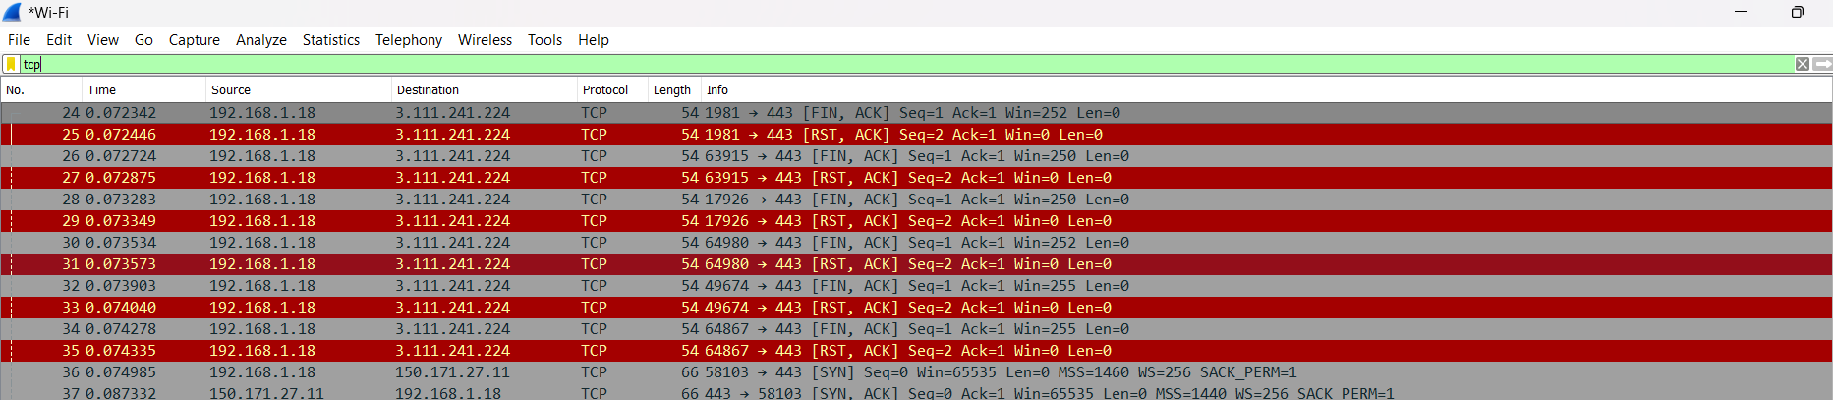

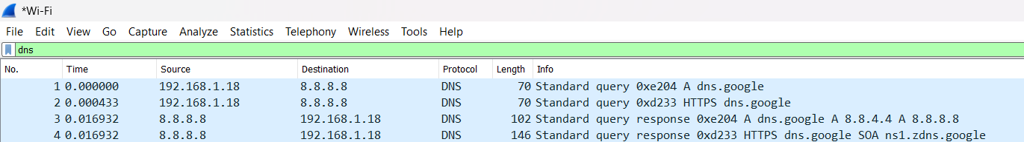

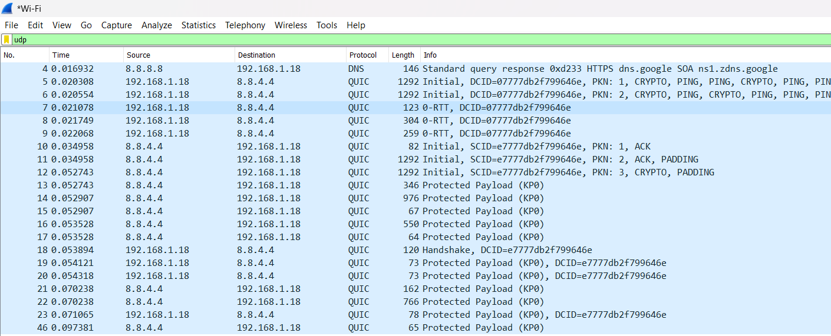

6.Export the capture as a .pcap file.

Save the capture file as .pcap file

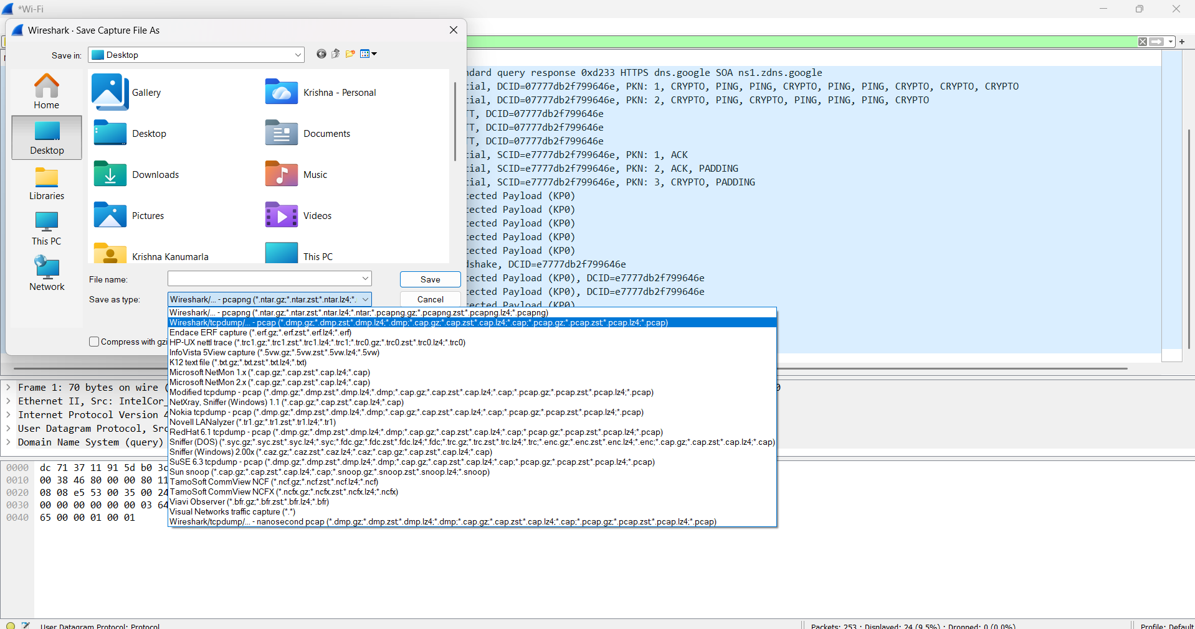

The Wireshark packet analysis indicates normal network operations with typical web browsing, DNS lookups, and background traffic. No major performance issues or security threats were identified in the theoretical capture. The network appears stable, with efficient communication between hosts and external servers.